Camera 2 Garage Gate Arm
429am Chrysler 300 enters garage
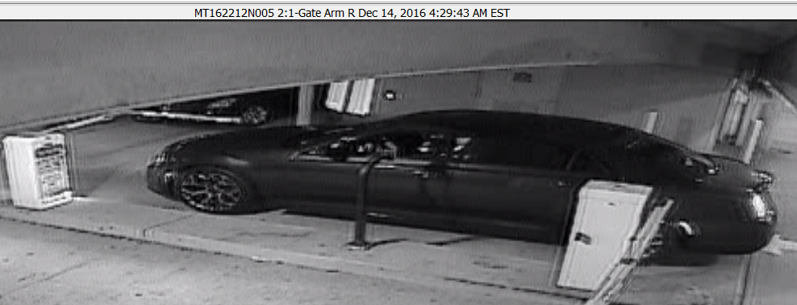
434am walks out of garage
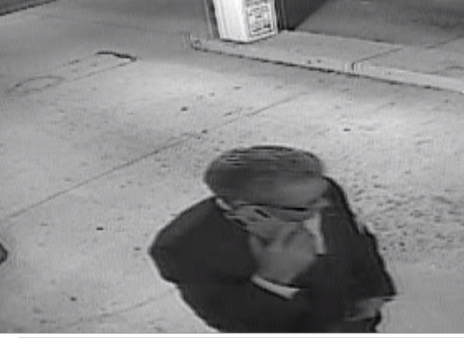
436am walks back in towards elevator
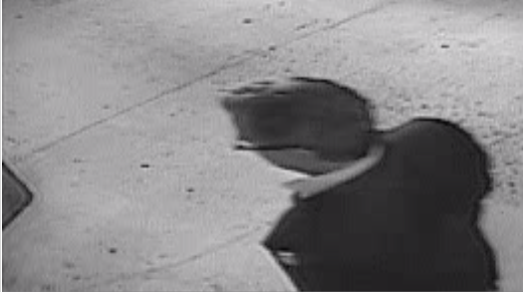
454am bmw enters garage
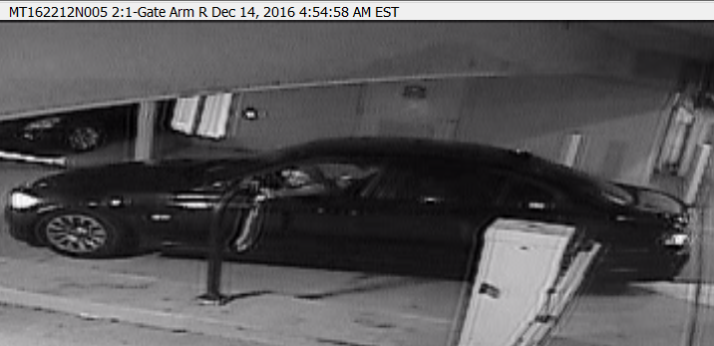
645am bmw exits garage
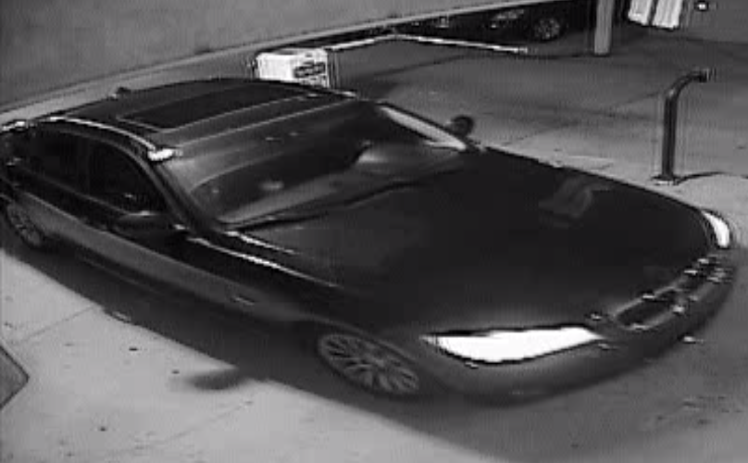
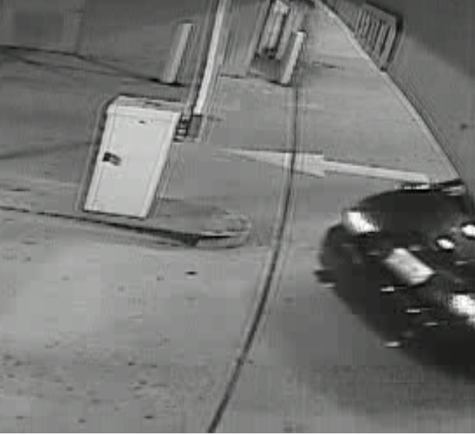
Turns left towards whole foods

Camera 3 Elevator A-1
450am victim exits
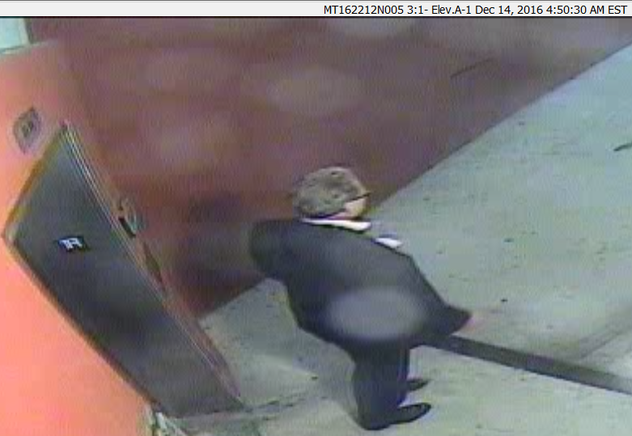
453am bearded subject approaches elevator
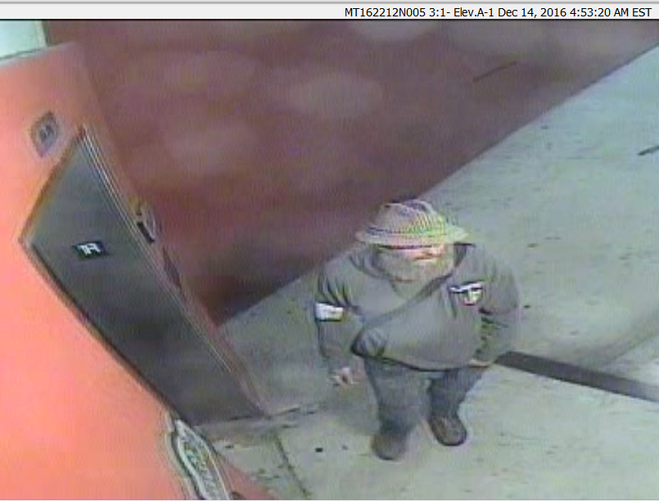
453 unable to enter elevator locates unlocked door
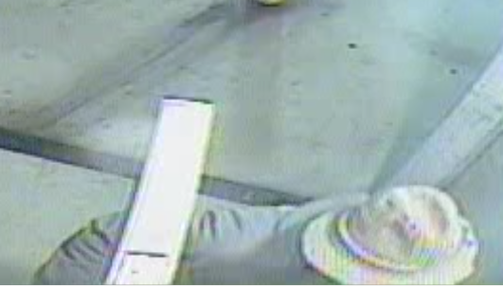
454 vehicle picks up possible victim just off camera
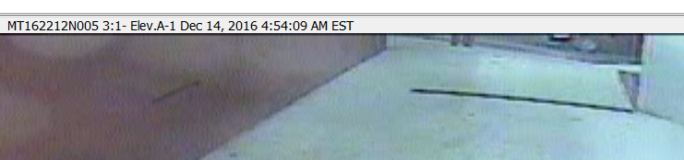
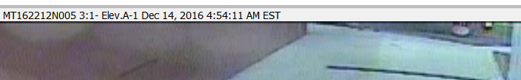
Camera 4 1-Elev A-2
436am Victim Enters Elevator
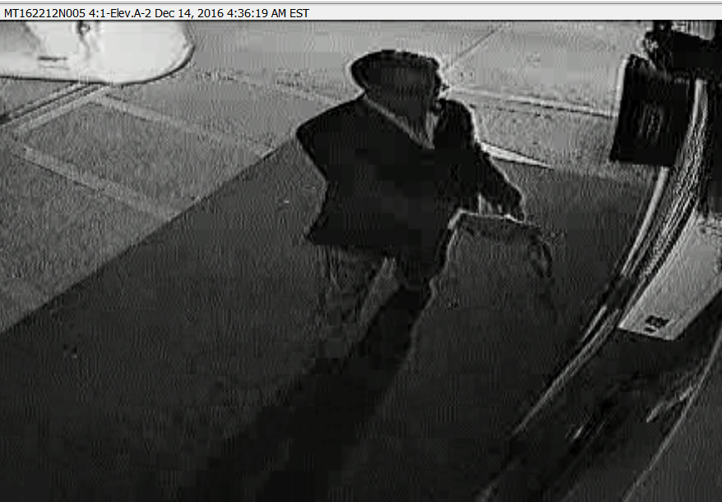
Camera 6 Elavator A
436am Victim enters from ground floor
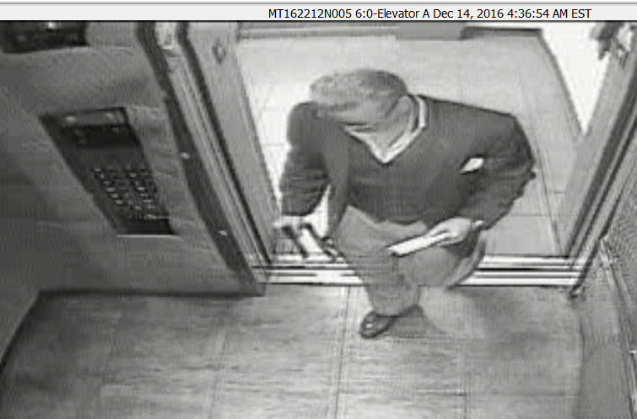
450am Victim enters from 5th floor talking on cell phone goes down exits elevator towards road (not garage)
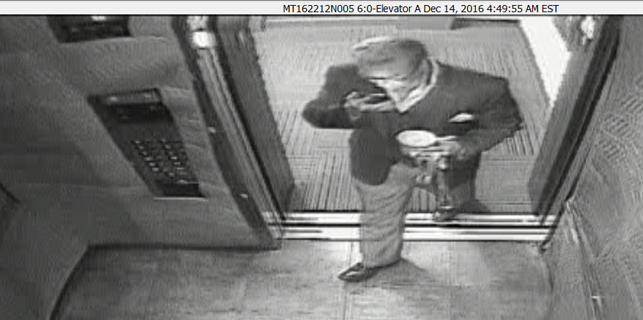
454am beard enters elevator ground level from garage side, pushes button for 5. Exits same time on 5
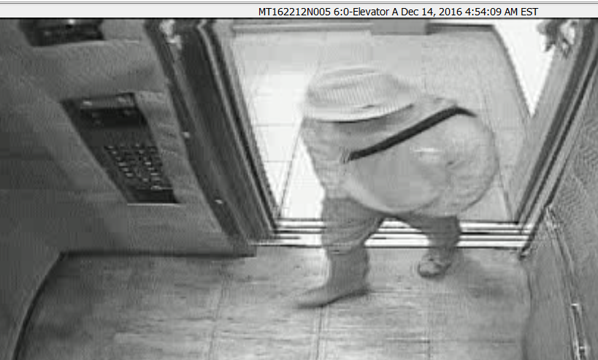
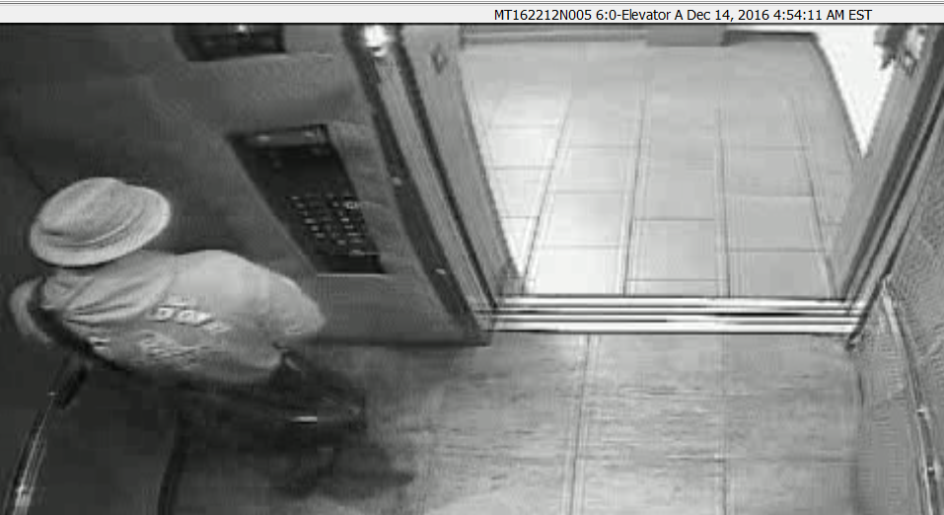
458 Beard reenters elevator (pushes door close no other buttons)
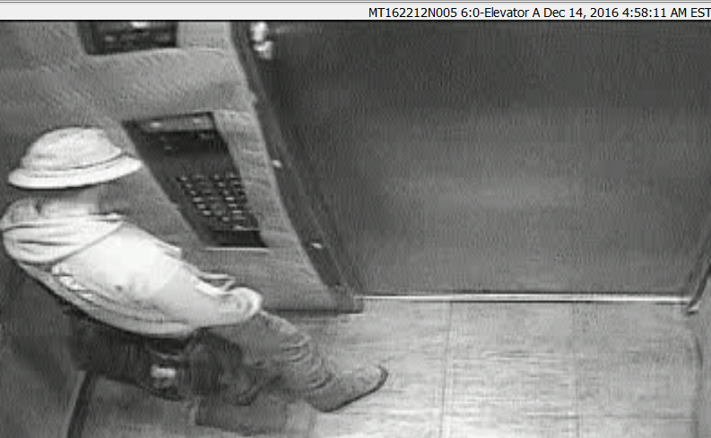
500am pushes door open buton and exits same floor (5)
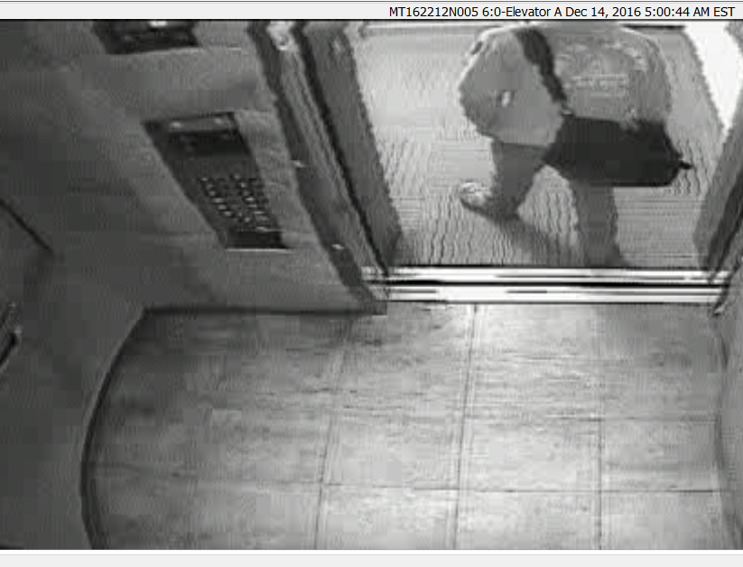
Camera 32 Level 5 Elevator B entrance
459am Victim enters with female subject
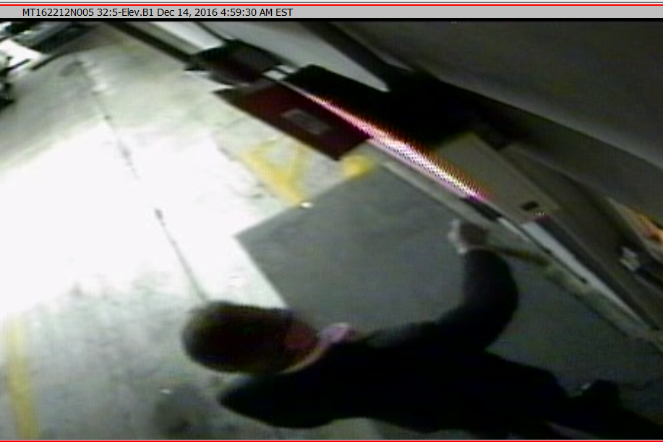
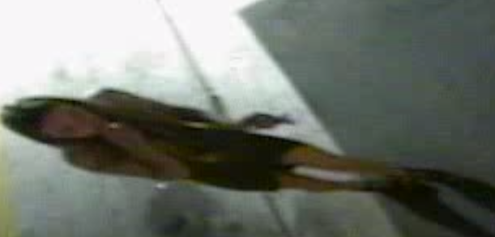
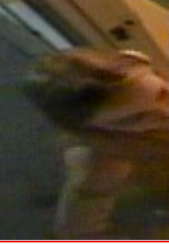
503am Bearded subject exits and props door open, walks around parking lot smoking cigarette. Subject appears to be wearing a shirt that says “Don’t Tread on Me”
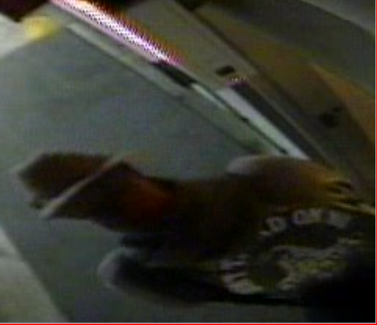
Reenters at 505am
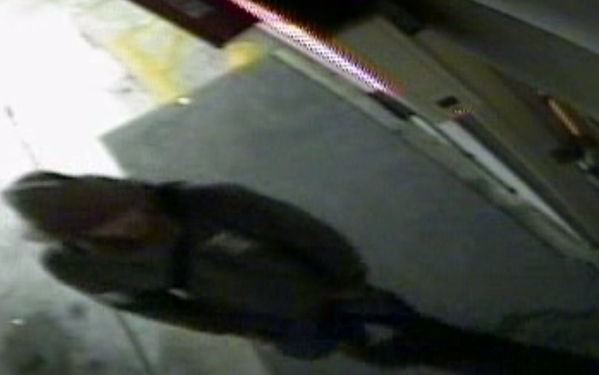
524am Victim and female subject exit wand walk to car
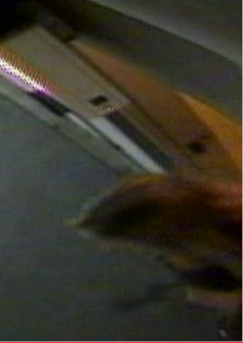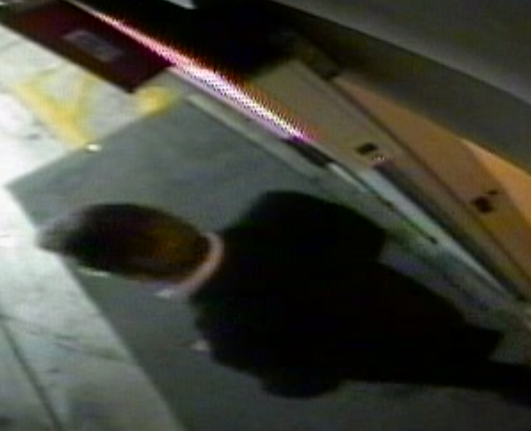
527am victim and female subject reenter
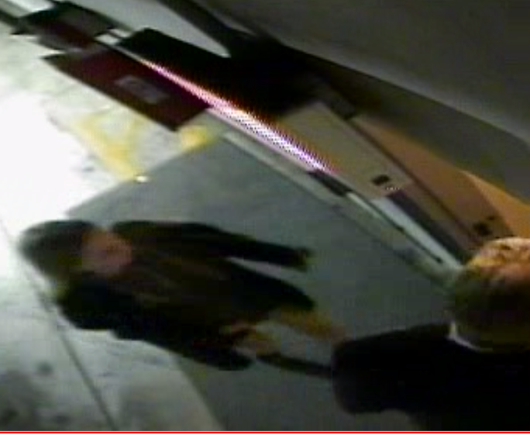
643am female subject runs out to vehicle
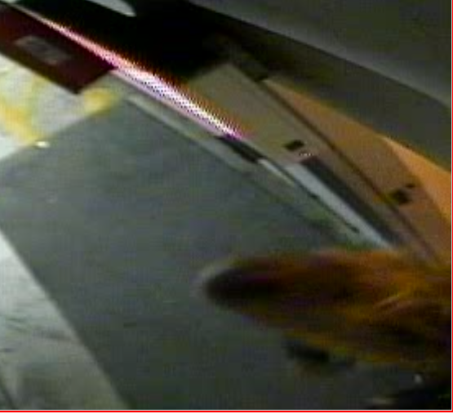
644 vehicle starts leaving
